SLEEP DISORDERS ASSOCIATES OF LANCASTER
250 RANCK AVENUE
LANCASTER, PA 17602
Phone: (717) 399-7451
Online Video Instructions: https://youtu.be/awa4z2fFn7A

Applying the ApneaLinkAir Home Sleep Testing Device
Fitting the belt
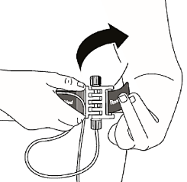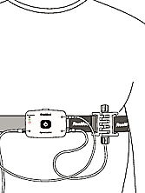
- Pull the assembled belt around your body. Step into the belt, as if putting on a pair of pants, and pull it above the nipple line. Adjust the Velcro strap to make it snug but not uncomfortable.
- Ensure that the ApneaLinkAir recording device is positioned center/midline and the belt rests underneath your arms.
Note: Wear the belt and monitoring device over a T-shirt/pajama shirt.

Fitting the nasal cannula
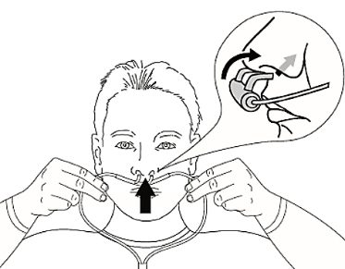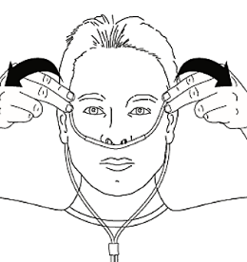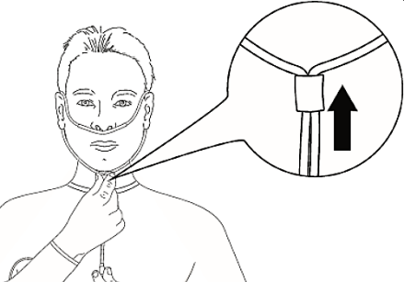
- Attach the nasal cannula to the monitoring device by connecting the cannula to the device and twisting the cannula until it locks in place.
- Insert the prongs into your nostrils; make sure the arc of the prongs is in the downward position (like the fangs of a snake).
- Loop the tubing around your ears.
- Pull the slider up towards you chin until the tubing is secure.
Note: Place the provided tape over the cannula at both sides of the nose to secure the tubing.

Fitting the pulse oximeter

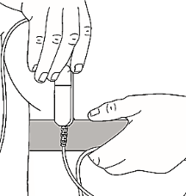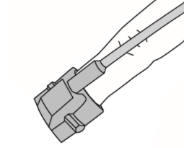
Posey Wrap or Tape
- Slide the oximeter clip onto the belt to the left of the ApneaLinkAir device.
- Slip the pulse oximeter over the index finger or middle finger of your left hand.
- Wrap the provided Posey Wrap or Tape around the base of the finger below the pulse oximeter (see above).
Operating the ApneaLinkAir Home Sleep Testing Device
Starting the test
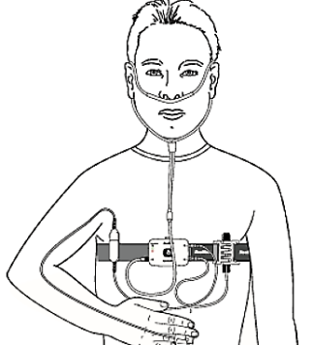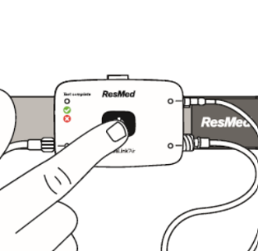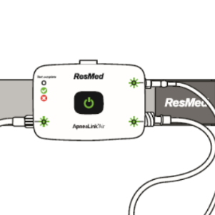
On Your Back
When properly set up, the system
looks like the image above.
- While positioned on your back, press and hold the power button for 3 seconds and then release it.
- The 3 monitoring lights will come on. It my take upwards of 30-45 seconds for them to light-up. Once the lights are green for 10 seconds, consider the test officially started. To fall asleep, you may remain on your back, or change positions if necessary.
- The lights will occasionally blink red, often as a result of movement. A blinking red light does not mean the device stopped recording. The blinking red light often goes green or goes out completely. If you notice a blinking light, ensure that the cannula is in your nose, the oximeter is on your finger, and the connections to the ApneaLinkAir device are secure; then go back to sleep. DO NOT FIXATE ON THE LIGHTS, IF YOU DO, YOU WILL NOT SLEEP. Make note of the blinking lights on your Morning Questionnaire.
Note: The doctor would like a minimum of 6-hours of recorded data. Once the test has started, go to sleep as normal as possible. The lights will dim-out after 10-minutes. This is normal; rest assured that the device has not power-off. If necessary, it is okay to get out of bed during the test; however, do not turn off the device, unless you are finished with the test. When making a bathroom trip, please remove the oximeter from your finger and place it over your right shoulder. Wash your hands and dry them after finished and reapply the oximeter and return to bed.

Stopping the test – check if test complete
On Your Back
Test complete light will be either red or green
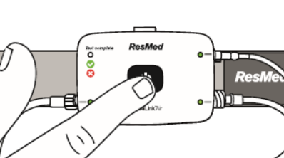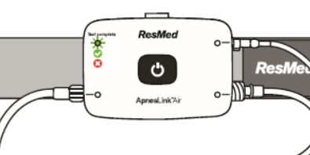
- While positioned on your back, press and hold the power button for 3 seconds and then release it.
- Verify that the test complete light is lit. The light will be either red or green
- Press and hold the power button for 3 seconds and then release it. All lights will be out and the device is powered-off.
Disassembly
- Carefully remove the belt, pulse oximeter, and nasal cannula. Throw away nasal cannula. Place equipment, along with Posey Wrap if used, into the bag.
- Fill-out paperwork.
- Return equipment.

